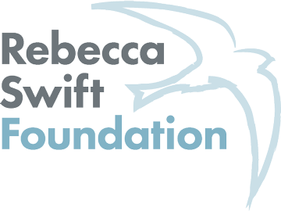

Equal Opportunities Monitoring Form

The Rebecca Swift Foundation is committed to eliminating discrimination from its selection processes. We believe no applicant will receive less favourable treatment either directly or indirectly, on the grounds of age, race, disability, gender identity, marital status, or sexual orientation.

This equal opportunities form is entirely anonymous and will not be shared with any third parties. The information provided will play no part in any selection process and will be treated in strict confidence. You may use the ‘Prefer not to say’ option available at each stage if you do not wish to answer a question.

Thank you for sharing your information with us; this will help us to monitor the Women Poets’ Prize impact, and assess the demographics of those applying to the award. This has a direct impact in turn on our ability to fundraise and continue to run the Prize.

You may complete the form by marking 'X' next to each relevant box. If you require the form in a different format, please contact us: info@rebeccaswiftfoundation.org

Gender identity Male Female Non binary Prefer not to say
Age 16-24 25-29 30-34 35-39 40-44 45-49
50-54 55-59 60-64 65+ Prefer not to say
What is your ethnicity?
Ethnic origin is not about nationality, place of birth or citizenship. It is about the group to which you perceive you belong. Please tick or write 'X' next to the appropriate box
White
English Welsh Scottish Northern Irish Irish
British Gypsy or Irish Traveller Prefer not to say
Any other white background, please write in:

Mixed/multiple ethnic groups
White and Black Caribbean White and Black African White and Asian Prefer not to say Any other mixed background, please write in:

Asian/Asian British
Indian Pakistani Bangladeshi Chinese Prefer not to say
Any other Asian background, please write in:

Black/ African/ Caribbean/ Black British
African Caribbean Prefer not to say
Any other Black/African/Caribbean background, please write in:

Other ethnic group
Arab Prefer not to say Any other ethnic group, please write in:
Do you consider yourself to have a disability or health condition?
Yes No Prefer not to say

What is your sexual orientation?
Heterosexual Gay woman/lesbian Gay man Bisexual
Prefer not to say If other, please write in:

What is your current working pattern?
Full-time Part-time Freelance Unemployed Prefer not to say

Do you have caring responsibilities? If yes, please tick all that apply
None Primary carer of a child/children (under 18)
Primary carer of disabled child/children
Primary carer of disabled adult (18 and over) Primary carer of older person
Secondary carer (another person carries out the main caring role) Prefer not to say

Thank you,

Rebecca Swift Foundation

